

**RYAN-SPORTS-CLUB**

**Supervisor:** *LÊ XUYÊN*

**Semester:** *01*

**Batch No:** *T1.2401.E0*

**Group No:** *02*

|  |  |  |
| --- | --- | --- |
| **Order:** | **Full name** | **Roll No.** |
| *1.* | *TRẦN CÔNG KHÔI* | Student1548610 |
| *2.* | *VŨ QUANG HUY* | Student1545473 |
| *3.* | *NGÔ TRUNG HIẾU* | Student1545745 |
| *4.* | *CAO VĂN THUẬN* | Student1545471 |

***Month****: 5* ***Year****: 2024*



**This is to certify that**

**Mr. TRẦN CÔNG KHÔI Mr VŨ QUANG HUY (CAP) Mr. NGÔ TRUNG HIẾU**

**Mr. CAO VĂN THUẬN**

**Have successfully Designed & Developed**

# RYAN-SPORTS-CLUB

Submitted by:

**Mr. TRẦN CÔNG KHÔI**

Date Of Issue:

17-Apr-2024

Authorized Signature:

**Mr. TRẦN CÔNG KHÔI**

**Content**

Content

Acknowledge

Synopsis

Problem Definition

Customer Requirements Specifications

Architecture and design of the project

1. Home page
2. Home page
3. Overview of page
4. Sports

1/Indoor

-Basketball field rental service.

-Tennis field rental service.

2/Outdoor Sports (product)

-Football field rental service

-Baseball field rental service.

3/Subscribe

-Membership

1. Gallery
2. Feedback, About us
3. Animated Slogan
4. About us
5. Thank lecture
6. Feedback Form
7. User

1.Sign Up

2.Sign In

3.History

1. Responsive web
2. Mobile
3. Tablet
4. Laptop

Task Sheet

**Acknowledge**

As we understand, the e-Project is a step-by-step learning environment that closely simulates the classroom and lab-based learning environments in actual implementation. It is a project implementation at your fingertips!! An electronic, live juncture on the machine that allows you to.

* Practice step by step, i.e., a laddered approach.
* Build a larger, more robust application.
* Usage of certain utilities in applications designed by the user.
* Single program to unified code leading to a complete application.
* Learn to implement concepts in a phased manner.
* Enhance skills and add value.
* Work on real-life projects.

Give a real-life scenario and help create applications that are more complicated and useful.

Mentoring through email support.

I want to start by expressing my gratitude to India Aptech for enabling my team to work on this amazing e-Project. This time, we had an excellent experience with e-Project.

Secondly, we would like to express my special thanks to our mentor Mr. Lê Xuyên for his time and efforts he provided throughout the project. Your useful advice and suggestions were really helpful to us during the project’s completion. In this aspect, we are eternally grateful to you.

In addition, despite a few mistakes we did during the project, we still hope to have additional chances to learn more about the field of web development. In the future, we'll make an effort to keep learning and developing.

In conclusion, once more, I sincerely thank our teacher and the school because of your support and valuable knowledge that you provided us.

Dear, Ho Chi Minh city, may 8th, 2024.

From group 2

**Synopsis**

Giving participants a model project to work on in preparation for actual projects is the aim of this program. These programs assist us in developing a more comprehensive program.

Instead of than teaching us HTML or JavaScript, the goal is to give us a real-world scenario and assist us in using the tools to construct simple apps.

As a result, we can edit the chapters before beginning the project.

For students like us who have finished the HTML5 lesson, this project is intended. These programs ought to be completed in lab sessions, with instructor support available if needed.

The website (in this project) is a tool that brings everything in the world to you such as historic monuments information natural knowledge and skill in technology...

It is imperative that we comprehend the topic matter thoroughly. We believe that we should work through the project and complete the assignments in accordance with the specifications. And respond to eprojects@aptech.ac.in by the deadline specified.

**Problem Definition**

RYAN Sports Club, an effort has been made to provide world class facilities

and infrastructure for the promotion of sports and health. During the past time, RYAN sports club has emerged as one of the best facilities in the country in the area of sports and health and also it is making strides to acquire a formidable presence in

the international. The club provides the facilities like “Indoor Sports”, Outdoor

Sports” and “Recreation”. All this information is required to be presented in

organized form for which a website is required to be created.

**Requirement Specification:**

The Web site is to be created based on the following requirements.

1. The Home Page with some description about the club with proper template designed. (also navigational link must be included.)
2. The link facilities like “Indoor Sports”, Outdoor Sports” and “Recreation”.
3. Membership link must be added in the website. (a dummy form is supposed to be fill and submitted).
4. List of the activities arranged yearly.
5. Suggestion and complaints.
6. Feedback.
7. Contact us.
8. Information must be added for each type of sports played (like rules, images, information, some famous players and Timings so on).
9. List of the top pf sports person can be added in the website.
10. Navigation facilities must be made précised in the application.
11. Picture gallery must be made added in the application.

**Hardware/ software requirement:**

**Software:**

* Notepad/HTML editor/CoffeeCup
* Angular/ angular15/react/bootstrap
* Dreamweaver/figma
* MS ie/ chrome/ firefox/ netcape/ MS edge

**Hardware:**

* A minimum computer system that will help you access all the tools in the courses is a Pentium 166 or better
* 64 Megabytes of RAM or better.

**Architecture and design of the project**

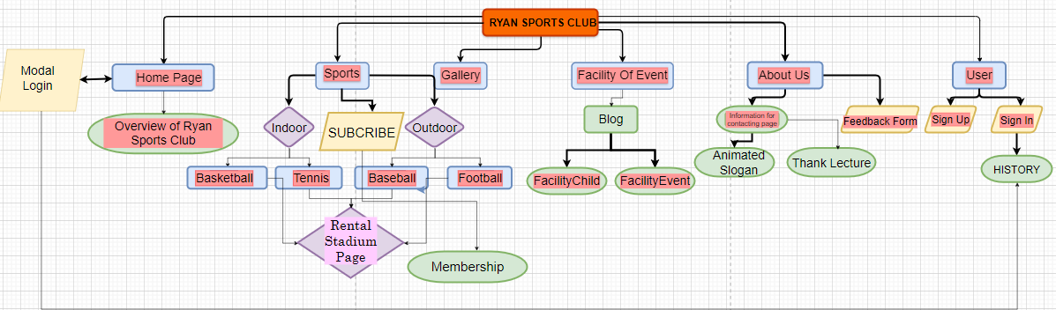

**III/ Facility of Event**

Click here to enter facility of event page



**1/** News and current event

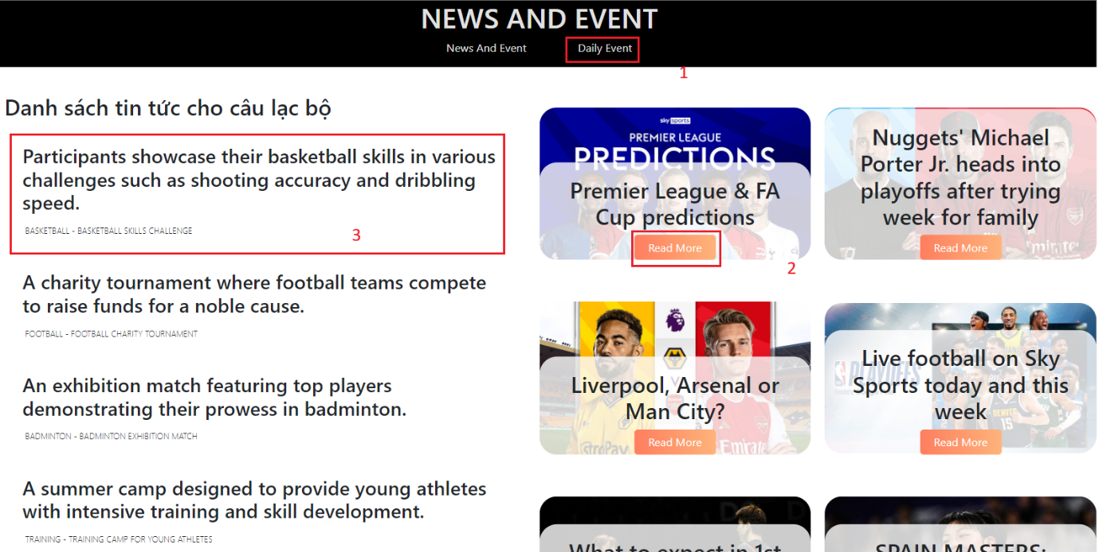

|  |  |  |  |
| --- | --- | --- | --- |
| **No** | **Type** | **Validation** | **Action** |
| 1 | Click |  | Navigation to the Daily Event Page |
| 2 | : Hover |  | The notification details card appears |
| 3 | Click |  | Navigation to the different news page |

2/ Daily Event

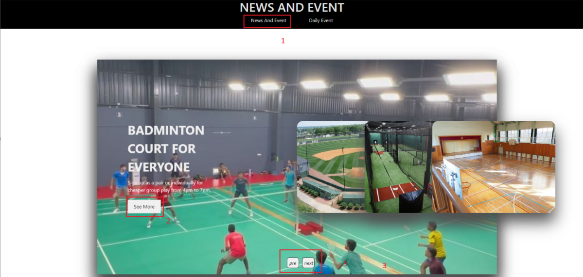

|  |  |  |  |
| --- | --- | --- | --- |
| No | Type | Validation | Action |
| 1 | Click |  | Navigation to the News and Event page |
| 2 | :  hover |  | See more information from the daily slide |
| 3 | Click |  | Next or Previous slide |

**IV/ ABOUT US**

- Click here to enter Contact Us page.



1/ ANIMATED SLOGAN

-Create an animated slogan by using Typer-Writer-Effect.

-This action according to a cycle.

-BEFORE:



-AFTER:



2/ ABOUT US

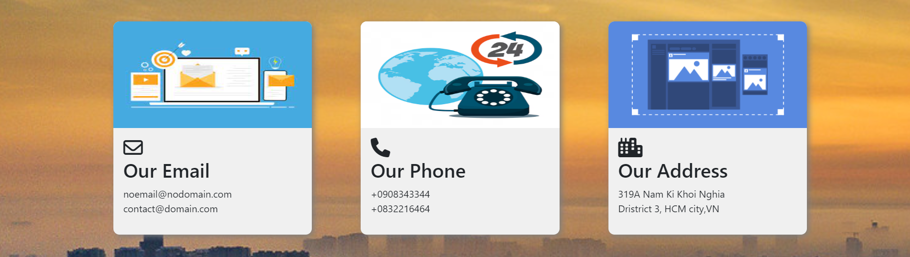

3/ Thank Lecture

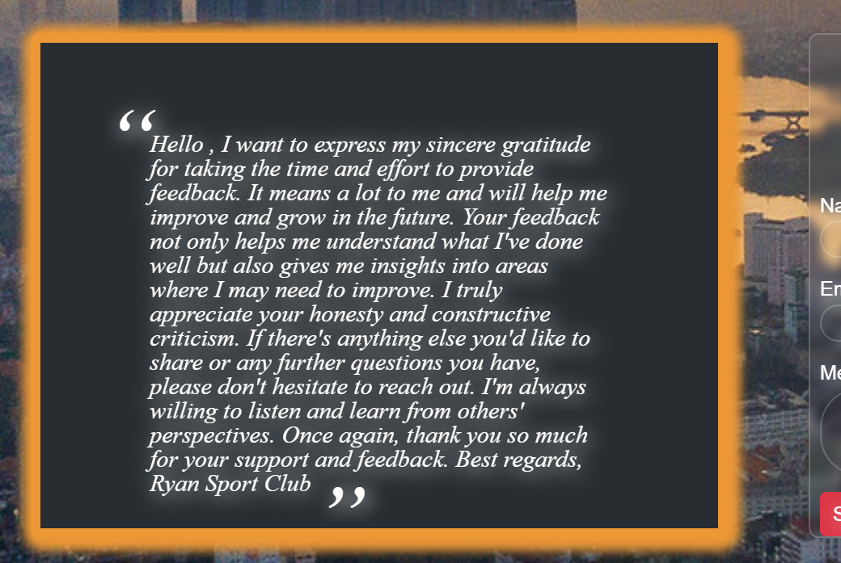

4/ Feedback Form

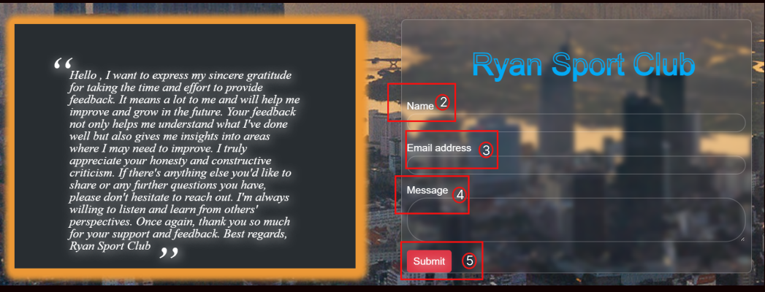

Log in to the site if you already have a member account

|  |  |  |  |
| --- | --- | --- | --- |
| **No** | **Type** | **Validation** | **Action** |
| 1 | Click |  | Navigation to About US Page |
| 2 | Text | Name is required!  Name must be a text! | Submit form without inserting name.  Submit form with inserting number in name input. |
| 3 | Text | Email is required!  (email structure: abc@gmail.com) | Submit form without inserting email and inserting a wrong email structure. |
| 4 | Text | Message is required! | Submit without inserting message. |
| 5 | Click | Send in successfully | To submit |

|  |  |  |  |
| --- | --- | --- | --- |
| **No** | **Type** | **Validation** | **Action** |
| 9 |  |  |  |
| 10 |  |  |  |
| 11 |  |  |  |
| 12 |  |  |  |
| 13 |  |  |  |
| 14 |  |  |  |
| 15 |  |  |  |
| 16 |  |  |  |
| 17 |  |  |  |
| 18 |  |  |  |

1. **Responsive web pages**

All Tasha pages (home, product, product detail, cart, blog, support, about us, login…)

are responsive in 3 sizes: mobile, tablet, laptop:

* Mobile format: width <= 767px
* Tablet format: 768px<=width<=1024px
* Laptop format: width>=1025px

**Below are some responsive example images:**

1. **Mobile**
2. **Tablet**
3. **Laptop**

**Task Sheet**